Concept mapping :-

1)A smart city traffic management system handles data related to vehicle movement, road networks, and
signal control. Construct a concept map connecting Primitive Data Structures → Non-Primitive Data
Structures → Linear → Non-Linear Structures. Include examples such as arrays, linked lists, trees, and
graphs, and illustrate their applications in traffic management. Explain the relationships between these
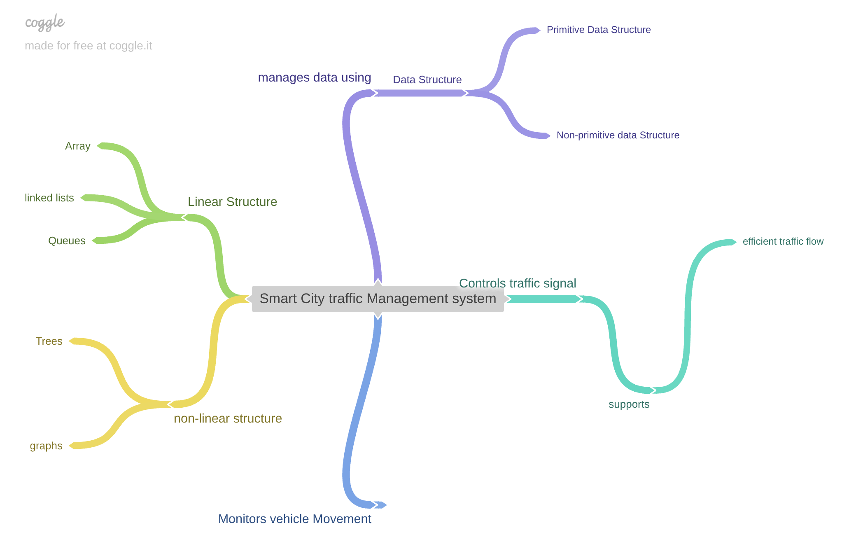
structures and justify their classification based on functionality and efficiency.
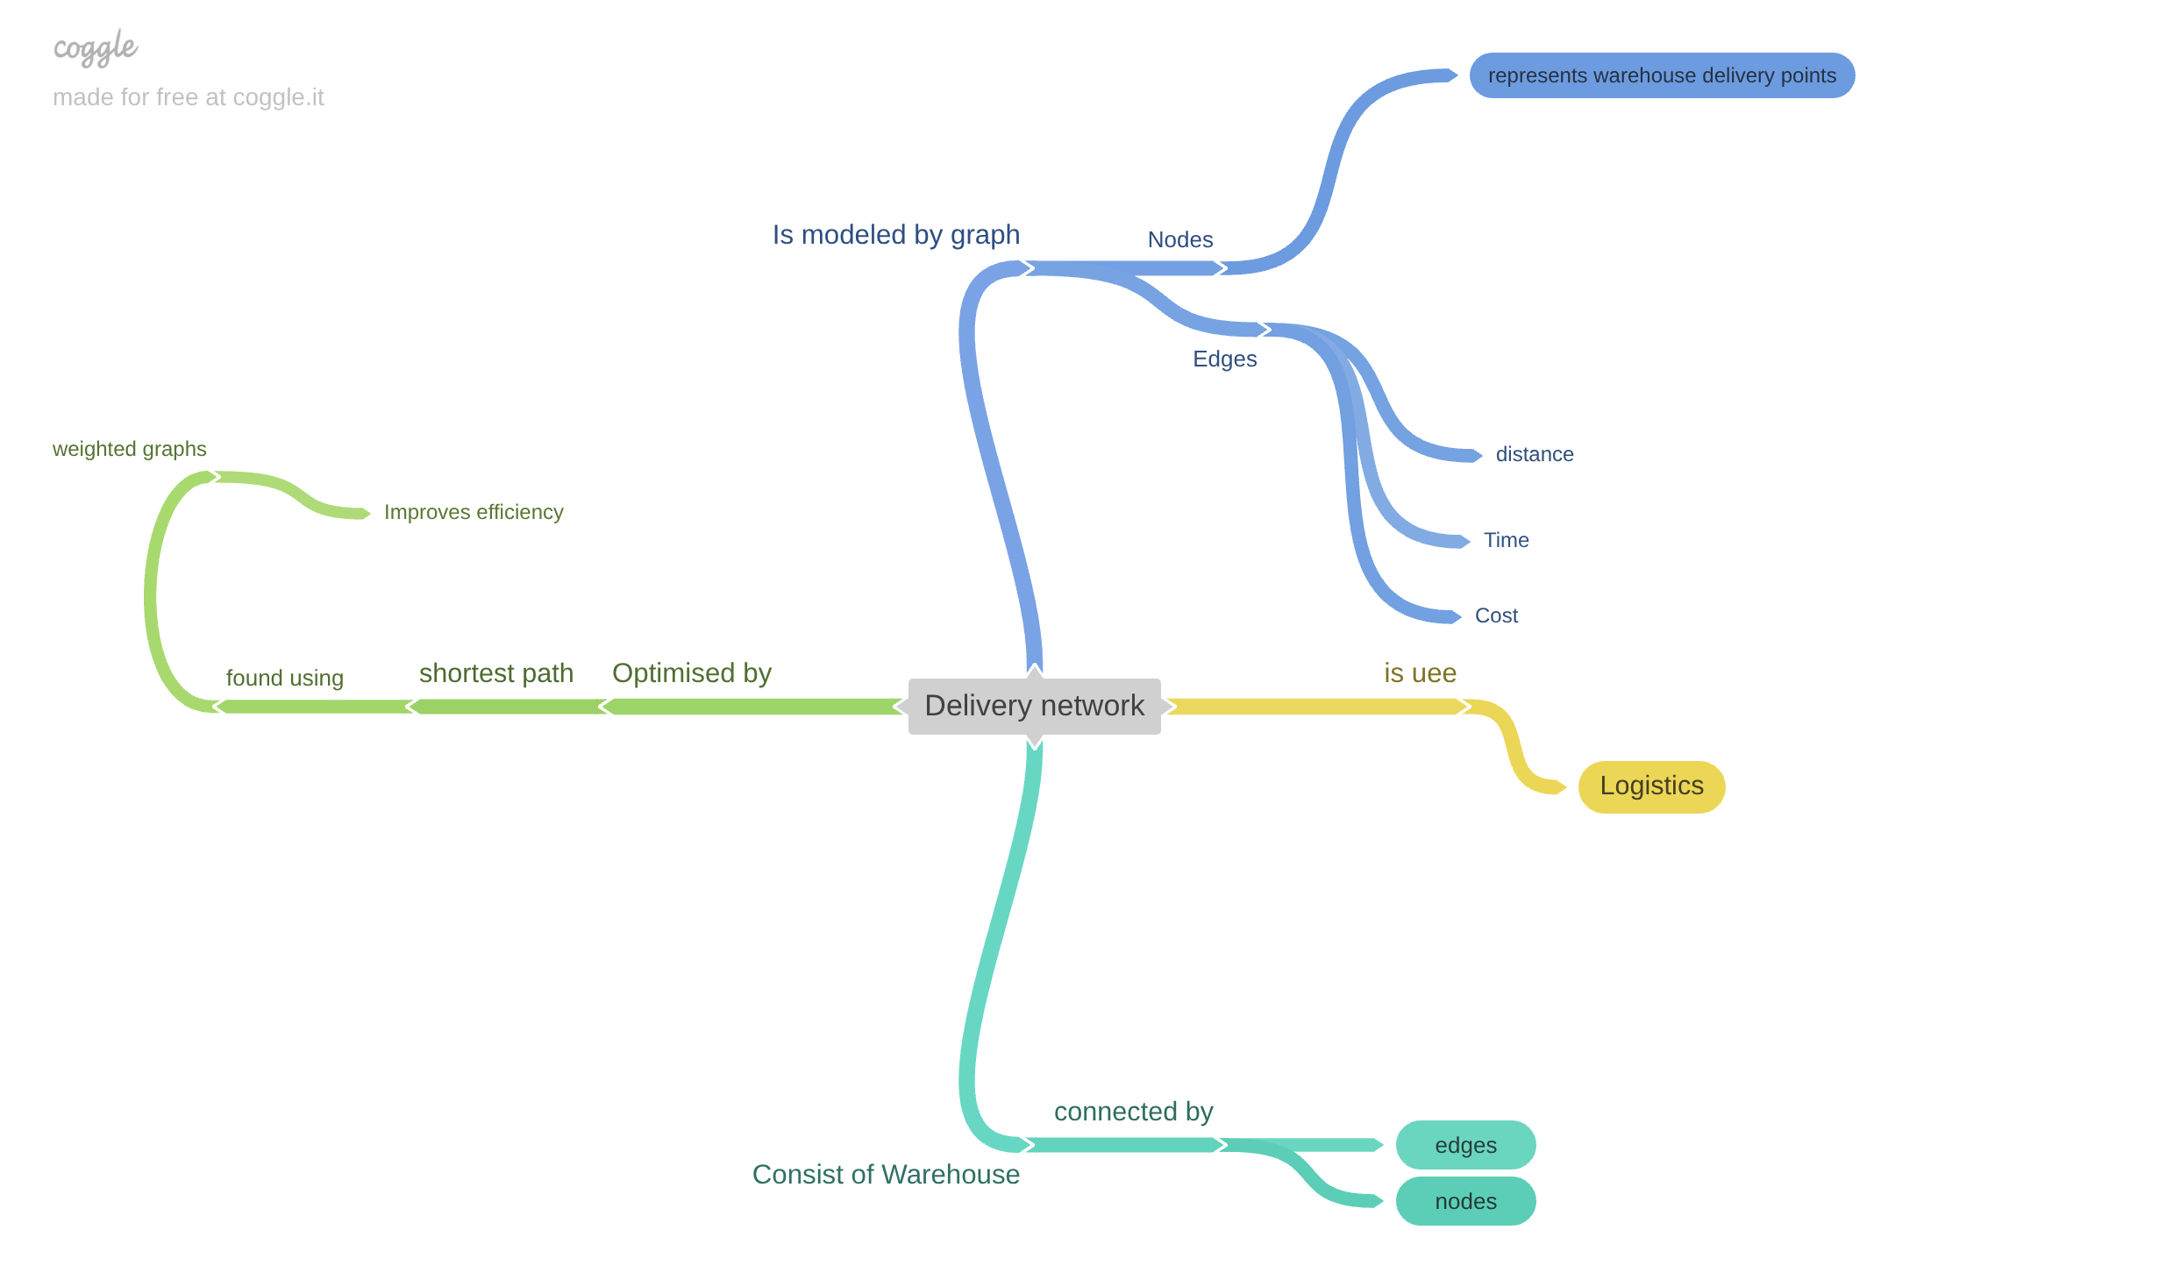
2) A delivery network connects multiple warehouses and delivery points. Construct a concept map connecting Graph → Nodes Edges → Weighted Graph → Shortest Path → Efficiency. Analyze how graphs model real-world networks and justify their use in route optimization.

